Analyzing The Cultural Values of Figurative Language Found in Pamona Songs

DEANE GLORIA GADI
Sintuwu Maroso Poso University, Indonesia
Email: deane.gloria1@gmail.com

IKA PARAMITHA LANTU
Sintuwu Maroso Poso University, Indonesia
Email: ika-lantu@unsimar.ac.id

Abstract. The aim of this study is to identify the types of figurative language found in Pamona songs and to analyze the cultural values of the Pamona people conveyed through the figurative language in these songs. Using a descriptive qualitative method, this study interprets data sourced from four Pamona songs used as teaching media in schools. The themes conveyed are the beauty of nature, love for the homeland, and advice. Then the cultural values found in the songs are togetherness and good manners. The figurative language within the songs' lyrics conveys cultural values and themes, helping to build students' character and strengthen their local identity while preparing them for a global world.
Keywords/Kata Kunci: Figurative Language, Pamona Songs, Cultural Values

INTRODUCTION
Fostering students' local, national, and international identities is crucial to preparing them for future challenges and opportunities. However, there are challenges related to student identity that arise from rapid social changes, migration, and the pressure to conform to certain norms. To address this, teachers play a vital role in shaping students' local identity, providing them with a strong foundation to become competitive global citizens.
One way to achieve this is through the local content subject (Mulok) organized by the Ministry of Education and Culture (Kemendikbud). In Mulok classes, both English and regional languages, such as the Pamona language, hold equal importance. The relationship between local culture and English language learning is close and mutually beneficial. Local culture can be a rich source of learning to enhance students' understanding of English, while English can be an effective tool to preserve local culture. In this way, students' local identity is not lost when they learn English. One medium that can be used to bridge these two is traditional songs. Traditional Pamona songs, in particular, use the Pamona language and are often used as learning materials to effectively instill cultural values. The figurative language in Pamona songs plays a crucial role as it can convey various aspects of Pamona community life, such as history, local wisdom, and cultural values.
Based on this background, this research aims to answer the problems formulation, they are: What are the types of figurative language found in Pamona songs, and what are the cultural values of the Pamona people conveyed through the figurative language in these songs.
This study uses a qualitative descriptive method to interpret data from four Pamona songs taught in schools, specifically in the local content subject. The researcher will identify the types of figurative language using the theory by Kennedy & Gioia (2005) and then identify the themes of the songs based on the theory by Nurgiyantoro (2010). After that, the researcher will explore the cultural values of the Pamona people conveyed through the song themes, based on the theories by Yakobus et al., (2019) and Imran et al., (2022).
Previous studies have examined cultural values in figurative language, but most have focused on foreign cultures. For example, there is research on figurative language that conveys American cultural values in Taylor Swift's pop songs. Other studies have used religious texts from Bali. The key difference between those studies and the present one is that previous research used objects from foreign cultures (pop songs) or religious texts, while this study specifically uses traditional Pamona songs as the object of research. Thus, this study aims to fill a "gap" in the literature by analyzing the cultural values in the figurative language found in Pamona songs.
This research aims to identify the types of figurative language found in Pamona songs and to analyze the cultural values of the Pamona people conveyed through the figurative language in these songs. This draft is expected to help teachers in selecting teaching materials that contain local culture, enriching the culture, and strengthening students' local identity.

LITERATURE REVIEW
This study focuses on the analysis of figurative language and the cultural values it contains. This research is built upon theoretical and empirical foundations that have been developed by experts in the field. In analyzing figurative language, this study refers to the theory put forward by Kennedy and Gioia (2005). This theory serves as a guide for identifying and classifying various types of figurative language found in texts, in this case, traditional Pamona songs. Through this framework, the researcher can systematically identify the use of metaphors, similes, personification, and other forms of figurative language.
To understand the core message or theme of these songs, this study applies the theory from Nurgiyantoro (2010). This theory provides a foundation for analyzing and interpreting the themes contained in literary works, including songs. By identifying the themes, this study can connect them to broader cultural values.
Furthermore, to examine the cultural values conveyed, this study uses the theoretical framework proposed by Yakobus et al. (2019) and Imran et al. (2022). These theories serve as a tool for interpreting how the figurative language in Pamona songs reflects and instills the cultural values of the local community, such as local wisdom, history, or a worldview.
Relevant previous research has extensively examined the relationship between figurative language and cultural values, although often focusing on different contexts. For example, some studies have analyzed figurative language that conveys foreign cultural values, such as those found in Taylor Swift's pop songs which reflect American culture. There are also studies that examine cultural values in more specific texts, such as religious texts from Bali.
However, these previous studies have fundamental differences from the present research. Most of those studies used objects from foreign cultures or religious texts, while this study specifically focuses on traditional Pamona songs as its main object. Therefore, this research aims to fill a "gap" in the literature by providing an in-depth analysis of the cultural values contained in the figurative language that is part of the rich local culture of Pamona.

METHOD
This study employs a descriptive qualitative research design. The qualitative approach was chosen to enable an in-depth, interpretive analysis of the textual data, which is essential for understanding the underlying cultural values and meanings within the figurative language. The descriptive method provides a systematic and detailed account of the phenomena observed in the research materials. The researcher's role as the primary instrument is integral to this design, as they are responsible for the interpretation and construction of meaning from the data.
The population for this study is the body of all traditional Pamona songs. From this population, a purposeful sample of four songs was selected. These specific songs were chosen because they are actively used as instructional materials for the local content subject in schools, making them highly relevant to the study's educational and cultural context. These four songs and their lyrics serve as the primary data and subject of this research.
Data collection was carried out through a documentary study, which involved a detailed analysis of the lyrics of the four selected traditional Pamona songs. The lyrics were sourced from credible documents and materials used in local schools. The researcher served as the main instrument (human instrument). To facilitate a systematic analysis, a data analysis sheet was developed to categorize and document the identified types of figurative language, song themes, and associated cultural values. The research did not involve human informants. The location of the research is the textual content of the selected songs, and the duration was the time required to complete the analysis. The validity of the research results is ensured by grounding all interpretations and conclusions in textual evidence from the song lyrics and established theoretical frameworks.
The data analysis was performed in a methodical, multi-stage process: The lyrics of each of the four songs were thoroughly analyzed to identify and classify the types of figurative language present, based on the theoretical framework of Kennedy & Gioia (2005). The main theme or core message of each song was then analyzed to understand the central narrative or message being conveyed, using the theory of Nurgiyantoro (2010) as a guide. The identified themes were subsequently linked to the cultural values of the Pamona community, referencing the theoretical frameworks of Yakobus et al. (2019) and Imran et al. (2022) to interpret how the figurative language reflects local wisdom, history, and cultural identity. The final step involved synthesizing the findings from the previous stages to interpret the relationship between figurative language and cultural values in Pamona songs. This process leads to the conclusions presented in the final section of the paper.

RESULT AND DISCUSSION
- Result
The analysis identified five types of figurative language across the four songs: simile, repetition, apostrophe, personification, and hyperbole. A total of 23 instances of figurative language were found in the lyrics of the songs titled "Poso Tanaku Ku Tanondo," "Lemba nTana Poso," "Yondo mPamona," and "Mosikola".

Table 1. Poso Tanaku Ku Tanondo Song
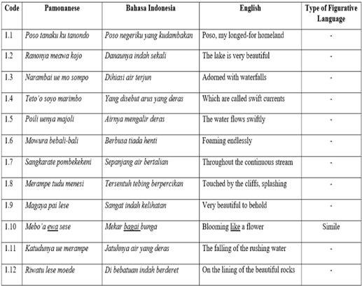

Table 2. Lemba nTana Poso Song
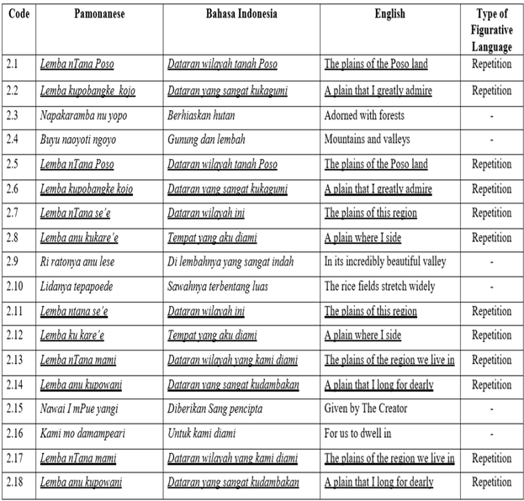
Table 3. Yondo mPamona Song
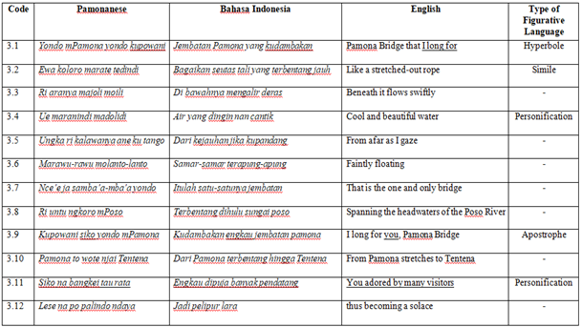

Table 4 Mosikola Song
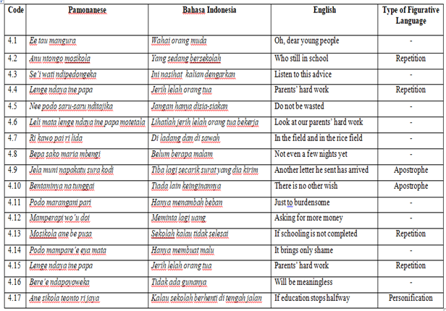

Based on a thorough analysis of the lyrics and the figurative language used, the songs were found to have the following themes: "Poso Tanaku Ku Tanondo": The Beauty of Nature, "Lemba nTana Poso": Love for the Homeland, "Yondo mPamona": The Beauty of Nature, and "Mosikola": Advice. All four themes were classified as belonging to the social level of themes according to Nurgiyantoro (2010), as they relate to human interaction with each other and with their natural environment.

Table 5. Figurative Language and Theme in “Poso Tanaku Ku Tanondo”
No | Data |  | Data Analysis | Theme
No | Pamonanese | English | Data Analysis | Theme
1. | 1.Mebo’a ewa sese | 1. Bloom like a flower | In these lyrics there is the word "ewa" which means "like" which clearly shows that the figurative language contained is a simile. This lyrics tells about the radiance of a waterfall blooming like a flower. | Throughout the lyric, the songwriter describes the beauty of nature of his homeland, which are Lake Poso and the Wera Saluopa waterfall.

Table 6. Figurative Language and Theme in “Lemba nTana Poso”
No | Data |  | Data Analysis | Theme
No | Pamonanese | English | Data Analysis | Theme
1. | 1. Lemba nTana Poso  2. Lemba kupobangke kojo  3. Lemba nTana Poso  4. Lemba kupobangke kojo  5. Lemba nTana se’e  6. Lemba anu ku kare’e  7. Lemba nTana se’e  8. Lemba ku kare’e  9. Lemba nTana mami  10. Lemba anu kupowani  11. Lemba nTana mami  12. Lemba kupowani | 1. The plains of Poso land  2. A plain I greatly admire  3. The plains of Poso land  4. A plain I greatly admire  5. The plains of this region  6. A plain where I side  7. The plains of this region  8. A plain where I side  9. The plains of the region we live in  10. A plain that I long for dearly  11. The plains of the region we live in  12. The plains of the region we live in | In these lyrics there are repetitions of sentences 4 times in each verse, and it has the same meaning. Because this song has 3 verses, the repetition occurs 12 times.  Thus, overall this song contains figurative language repetition. | Throughout this song, the songwriter telling the story of his homeland which he really longed for, which was decorated with mountains, valleys, rice fields neatly lined up and so on. Based on the repeated sentences, it shows that the songwriter want to declare that he really loves his homeland. So the theme of this song is love of The homeland.

Table 7. Figurative Language and Theme in “Yondo mPamona”
No | Data |  | Data Analysis | Theme
No | Pamonanese | English | Data Analysis | Theme
1. | Yondo mPamona yondo kupowani | Pamona bridge that I long for | In this lyrics, the word I long for identified as hyperbole because this is exaggerating something. It is too much if someone longs for a bridge. | Throughout this song, the songwriter describes the yondo mPamona as the icon of Tentena city. This bridge is very popular with many people because of its beauty and also the story behind its construction.  The theme of this song is the beauty of nature.
2. | Ewa koloro marate tedindi | Like a streched-out rope | In this lyrics, the word “like” make it identified as a simile. The pamona bridge look like a streched-out rope over the Poso River
3. | Ue maranindi madolidi | Cold and beautiful water | The word beautiful refers to water, this makes it classified as personification because it is the giving of human characteristic to water.
4. | Kupowani siko yondo mPamona | I long for you, Pamona bridge | The word “siko” or “you” refers to the Pamona Bridge itself. The songwriter seems to be speaking to the Pamona Bridge, which is an inanimate object, which makes it classified as an apostrophe.
5. | Siko na bangkei tau rata | You adored by many visitors | The lyrics of this song are considered Personification because they contain the word “bangkei” or “adored”. This refers to the Pamona bridge which is adored.

Table 8. Figurative Language and Themes in “Mosikola”
No | Data |  | Data Analysis | Theme
No | Pamonanese | English | Data Analysis | Theme
1. | 1. Anu ntongo mosikola  2. Mosikola ane be pusa | 1. Who still in school  2. If schooling is not completed | The word “mosikola” is repeated twice throughout the song, so the lyrics contains repetition, which emphasizes how important school is. | Overall, this song is a reminder for every young people who is still in the process of education, not to waste their parents' hard work in sending them to school.  Thus, this song theme is advice.
2. | 1. Lenge ndaya ine papa  2. Lenge ndaya ine papa | 1. Parents’ hard work  2. Parents’ hard work | This lyric is repeated twice throughout the song, so the lyrics contains repetition, which means the hard work of parents  Should be appreciated and should not be wasted.

- Discussion
A. The Types of Figurative Language Found in Pamona Songs
According to Kennedy & Gioia (2004) figurative language is a language that used to create artistic effects and deeper meaning. There were 10 types of figurative language. However, in this research, the researcher only identified 5 types of figurative language in the lyrics of 4 Pamona songs, they are simile, repetition, apostrophe, personification, and hyperbole. In the findings section, the researcher identified the types of figurative language and also the themes present in Pamona songs, entitled "Poso Tanaku Ku Tanondo", "Lemba nTana Poso", "Yondo mPamona", and "Mosikola". The types are 15 repetitions, 2 similes, 3 apostrophe, 2 personification, and 1 hyperbole. Therefore, the total number of figurative language devices found in the four Pamona songs was 23. Here is the explanation.
- Simile
According to Kennedy & Gioia (2004) Simile is a figurative language that expresses the similarity of an object, but the thing being compared is not the same object. We can say that some sentences are similes when two things are not only compared but the emphasis is added by stating that one exceeds the other in intensity. The characteristic of simile is the use of the words "like" and "as" when comparing them. As shown in the findings section of the lyrics of the Pamona song, "meboa ewa sese" or in English "bloom like a flower" in the song Poso Tanaku Ku Tanondo with data code 1.10, which is a simile. In this lyric, the songwriter describes the beauty of his homeland like a blooming flower, a blooming flower is famous for its beauty. Simile also found in Pamona Song Yondo mPamona, with data code 3.2 “ewa koloro marate tedindi” or in English “Like a streched-out rope”. The songwriter describe how Yondo mPamona looks like from afar. Based on the figurative words found, this song has a theme of natural beauty.
- Repetition
According to Kennedy & Gioia (2004) Repetition is a repetition figure where the repetition of the word serves to convey the meaning that is in the word or series of words. It is not only for entertaining repetition is also used when songwriters and poets want to give it to a certain part to convey meaning properly. As shown in the findings section of the lyrics of the Pamona song, Lemba ntana Poso with data code 2.1 and 2.5, “Lemba kupobangke kojo” with data code 2.2 and 2.6, or in english “The plains of the Poso land”, “A plains that I greatly admired”, next “Lemba ntana se’e” with data code 2.7 and 2.11, “Lemba ku kare’e” with data code 2.8 and 2.12, in english “The plains of this region”, “A plain where I side”, then “Lemba ntana mami” with data code 2.13 and 2.17, “Lemba anu ku powani” with data code 2.14 and 2.18 or in english “The plains of the region we live in”, “A plain that I long for dearly”. In this song there are many repetitions of the same words, which emphasizes the feelings of the songwriter for his homeland. He longs for it, he is very proud, he misses his homeland very much. Based on the figurative language found, the theme of this song is love of the homeland. According to the theme categorization theory from Nurgiyantoro (2010), this theme is classified as a social theme, because social themes are related to the relationship between humans and nature. Repetition is also found in the song titled Mosikola, in the word “Mosikola” or in English “School” with the data code 4.2 and 4.13 This word repeated twice, which emphasizes that school is very important. “Lenge ndaya ine papa” or in English “Parent’s hard work” with the data code 4.4 and 4.15. In the lyrics, the songwriter wants to emphasize the struggle of parents to send their children to school, and should be appreciated also should not be wasted. Based on the figurative language found, the theme of this song is advice.
- Apostrophe
According to Kennedy & Gioia (2004), apostrophe is a figure of speech where a person or something that exists or does not exist is considered to be there. As shown in the lyrics of song titled Yondo mPamona with the data code 3.9, “Kupowani siko yondo mPamona” or in English “I long for you Pamona bridge”. The word “siko” of “you” refers to the Pamona bridge itself. This is classified as an apostrophe because the Pamona bridge is an object, which is does not exist. Apostrophe also found in song titled Mosikola, with the data code 4.9 “Jela muni napakatu sura kodi” or in English “Another letter he sent has arrived” and 4.10. “Bentaninya na tunggai” or in English “There is no other wish”. The word “na” means “he or her” refers to the person that did not exist, that is why he or her sent a letter. Based on the figurative language found, the theme of this song is the beauty of nature. According to the theme categorization theory from Nurgiyantoro (2010), this theme is classified as a social theme, because social themes are related to the relationship between humans and nature.
- Hyperbole
According to Kennedy & Gioia (2004), hyperbole is a figure of speech that exaggerates something excessively to create a dramatic or humorous effect. Hyperbola usually contains statements that are clearly impossible to happen. As shown in the lyrics of Pamona song with the data code 3.1, "Yondo mPamona yondo kupowani" or in English “Pamona bridge that I long for”, it is described how the songwriter longs for the Pamona bridge. The word “Kupowani “ or “I long for” is identified as hyperbole because this word seems to be an exaggeration. It is too much if someone longs for a bridge. Hyperbole also found in the lyrics “Siko na bangkei tau rata” or in English “You adored by many visitors” with the data code 3.11. The word "bangkei" or "adored" is an expression of the songwriter towards the beauty of the Pamona Bridge. Because it is so beautiful, visitors adore the Pamona Bridge. This is considered hyperbole because the word adored is too much to describe the beauty of a bridge, namely the Pamona Bridge. Based on the figurative language found, the theme of this song is the beauty of nature.
- Personification
According to Kennedy & Gioia (2004), Personification is a figure of speech for a thing, animal, or abstract terms like truth or nature is made a human. In other words like humans, we humanize or give life to any difference or give human-like characters to random objects or others. As shown in the lyrics with the data code 3.4 “Ue maranindi madolidi” or in English “Cold and beautiful water”. Personification shown directly in word “Madolidi” or “beautiful”. And in the data code 3.11 “Siko na bangkei tau rata” or in English “You are adored by many visitors” in song titled “Yondo mPamona”. The lyrics of this song are clasified personification because they contain the word “bangkei” or “adored”. The giving of human characteristic that can be adored for their beauty or other characteristic to a Pamona bridge, makes this lyric classified as personification. Based on the figurative language found, the theme of this song is the beauty of nature. According to the theme categorization theory from Nurgiyantoro (2010), this theme is classified as a social theme, because social themes are related to the relationship between humans and nature. According to the theme categorization theory from Nurgiyantoro (2010), this theme is classified as a social theme, because social themes are related to the relationship between humans and nature. Hyperbole also found in the lyrics “Ane sikola teonto ri jaya” or in English “if education stops halfway” with the data code 4.17 in song titled “Mosikola”. It classified as personification because chools are given human-like characteristics, which can stop in the halfway. School is a dead object that cannot move. Based on the figurative language found, the theme of this song is the beauty of nature
B. Themes That conveyed through Figurative Language Found in Pamona Songs
“Theme is the basic idea that unites a story, song, or literary work, making it easy to understand and enjoy. Themes function as concepts, elements, descriptors, and attributes. A song without a theme will feel dry, unclear, and lifeless” (Sa’adah 2020). The theme itself is divided into several levels. According to Nurgiyantoro (2010), there are 5 levels of theme, namely the physical level, the organic level, the social level, the individual level, and the divine level. Based on the findings of the researcher, the four Pamona songs entitled Poso Tanaku Ku Tanondo, Lemba nTana Poso, Yondo mPamona, and Mosikola, are all classified as social themes. Here is the explanation
- Poso Tanaku Ku Tanondo
In this song, there is one type of figurative language namely simile. Simile appears 1 time. In the lyrics "Meboa ewa sese" or "Bloom like a flower". The songwriter describes the beauty of nature in Tana Poso blooming like a flower. Based on its meaning, this song has the theme "The Beauty of Nature". According to the theory of theme classification Nurgiantoro (2010), the theme of natural beauty is classified as a social level theme. This is because the social theme includes the relationship between humans and nature.
- Lemba nTana Poso
In this song, the figurative language of the repetition type almost dominates the entire song, repetition appears 12 times. The songwriter uses figurative language of the repetition type to emphasize how much he loves his homeland. This makes the theme of this song explicitly shown, namely the theme of "Love for the Homeland". The theme of love for the homeland itself according to the theory of theme classification from Nurgiyantoro (2010) is classified as a social level theme, today because the theme of the social level contains the social problem including love.
- Yondo mPamona
In this song there are 4 types of figurative language found, they are hyperbole which appears 1 time, simile appears 1 time, personification 2 times, and apostrophe 1 time. The songwriter uses 4 figurative languages at once to describe the beauty of the pamona bridge that stretches over the poso river. Based on the overall lyrics and also the figurative language used, the theme of this song is "The Beauty of Nature". According to the theory of theme classification Nurgiantoro (2010), the theme of natural beauty is classified as a social level theme. This is because the social theme includes the relationship between humans and nature.
- Mosikola
In this song there are 3 figurative languages found, repetition appears 4 times, personification 1 time, and apostrophe 2 times. The songwriter uses these three figurative languages to describe how parents struggle to get the best education for their children. Based on the overall meaning of this song, the theme is "Advice". According to the theory of theme classification of Nurgiyantoro (2010), this song is included in the category of social themes, because in it there is a relationship between humans and each other.
C. Cultural values found in Pamona Songs and Its Relevance With Global Culture
Pamona cultural values are the guidance in live of the Pamona people who are spread across several areas in Poso district, Central Sulawesi. According to Yakobus, et al., (2019) The Pamona tribe has a culture called Sintuwu Maroso. Sintuwu Maroso culture is the local culture of the pamona’s people contains values that are believed to be very beneficial in life public. Based on the definition according to Yakobus et.al (2019) and Imran (2022), it was concluded that the values of Pamona culture include togetherness, good manners or politeness, brotherhood, tolerance, solidarity, unity and also democracy. Of the seven cultural values identified, only two were found in the lyrics of Pamona songs, they are togetherness and good manners or politeness where the song contains an advice. Here is the correlation with students' character, in terms of students' local identity.
- Togetherness
This value is implemented in principles life of supports each other (Yakobus et al., 2019). Togetherness in the Sintuwu Maroso culture is not only seen from activities of helping each other among fellow human beings, but togetherness can also be realized in community mutual cooperation in protecting and preserving the surrounding environment, because nature is part of the life of the Poso community. The three of Pamona songs titled “Poso Tanaku Ku Tanondo”, “Lemba ntana Poso” and also “Yondo mPamona” has the theme love for the homeland and also the beauty of nature. Both of these themes are related to nature. Togetherness is correlated with the social level theme which are beauty of nature and also love for the homeland, because as a local community we must work together to protect and care for the natural beauty of our land, so that it remains sustainable. This can encourage students to participate in mutual cooperation activities in the community. This experience strengthens the sense of solidarity and social responsibility. This cultural value is relevant to the global cultural values put forward by the OECD, namely Global Mindedness, where it involves a sense of responsibility and interconnectedness with the global community. It is also relevant with another global culture from Paragae (2023), which are flexibility and adaptability and also good communication with various backgrounds.
- Good Manners or Politeness
Good manners is implemented in the principle of mutual living respect and appreciate (Yakobus et al., 2019). Metubunaka is very important in creating harmony and peace in society, considering that so far the emergence of social problems such as disputes between communities originates from a lack of sense of metubunaka, whether between parents and children, between neighbors and neighbors, or between fellow citizens (Imran et al., 2022). One of the Pamona songs titled “Mosikola” has the theme of advice. Good manners or politeness is correlated with the social theme which is advice, because it contains a message for young people to respect and appreciate the hard work of their parents in their efforts to provide the best life for their children, by completing their education well. This can encourage students to participate in mutual cooperation activities in the community. This experience strengthens students character to speak politely, be respectful to their elders, respect their peers, and be polite in interacting with anyone. This cultural value is relevant to the global cultural values put forward by the OECD, namely intercultural relations, where it is very important to instill the value of respect for any differences, be it age, background, culture and so on.

CONCLUSION
Based on the analysis conducted in the previous section, the lyrics of the Pamona song use several types of figurative language to convey the themes of the songs and also the cultural values. The themes contained in Pamona songs are the beauty of nature, love of the homeland, and advice. All of them are classified as social themes, because they contain social problems such as human relations with nature and with each other. The cultural values contained in the 4 songs are togetherness and good manners. These cultural values are also relevant to global culture, namely global mindedness, good communication, and flexibility and adaptability.
The cultural values contained in Pamona songs can be used to build the character of students, in order to strengthen regional identity, namely togetherness and also good character. This is also can prepare students to enter the global world, because local cultural values are relevant to global culture. These cultural values can be a means of developing the character of students, with educators acting as filters or extractors of the essence of these songs to teach character values through figurative language that has been explained previously such as repetition, simile, hyperbole, personification, and apostrophe.

REFERENCES
Arif, K. M., Saeduzzaman, A., & Student, M. (2015). Economic Globalization and Income Inequality in Bangladesh. Bangladesh Journal of Political Economy, 31(2), 115.
Imran, I., Septiwiharti, D., & Nasran, N. (2022). Budaya Sintuwu Sebagai Kearifan Lokal Di Desa Tindoli Kecamatan Pamona Tenggara Kabupaten Poso. Jurnal Pendidikan dan Konseling (JPDK), 4(5), 4225-4234.
Kennedy, X.J. And Gioia. D. (2005). An Introduction to Poetry. (Ed. 11). United States: Longman
Mridha, Md. A. H. (2021). Global Culture: Its Existence and Consequences on Our Lifestyle in Bangladesh. Open Journal of Social Sci ences , 9,167-187. https://doi.org/10.4236/jss.2021.91012
NASRULLAH, A., & Dewi, F. A. I. (2023). AN ANALYSIS OF FIGURATIVE LANGUAGE IN SONG LYRIC BY QUEEN: A NIGHT AT THE OPERA ALBUM AND IMPLICATION IN ENGLISH EDUCATION PERSPECTIVE (Doctoral dissertation, UIN Surakarta).
Neil J, S., & Paul B, B. (2001). International Encyclopedia of the Social & Behavioral Sciences. Pergamon.
Nurgiyantoro, Burhan. 2010. Teori Pengkajian Fiksi. Yogyakarta: Gadjah Mada University Press.
Publication, Gjr. (2024). Semantics in Theory and Practice. 4. 12-16. 10.5281/zenodo.10724514.
Sa'adah, K. (2023). Themes In The Song Lyrics Bandaids Mini Album By Keshi And Its Contribution To Poetry Teaching. Jurnal Bima, 1(4), 275-286.
Sita, I. G. A. P. J., Devi, N., Widiastuti, N. M. A., & Qomariana, Y. (2021). The Cultural Values of Figurative Expressions in the text Mother Parvati Curses Citraketu. Lekesan: Interdisciplinary Journal of Asia Pacific Arts, 4(2).
Slideshare.com. 26 June 2018. Global Competency-for-an-inclusive-world. Accessed on 12 March 2024, from https://www.slideshare.net/DrLendySpires/global-competencyforaninclusiveworld
Suriyawongpaisal, W. (2013). A study of figurative language that conveys connotation related to American cultural values in pop songs: the case of Taylor Swift. Manutsayasat Wichakan, 20(1), 241-261.
untuk Mewujudkan, M. P. P. V., Kelola, T., yang Baik, P., Nasional, K., & Dunia, A. I. B. (2017). Pengaruh Globalisasi terhadap Eksistensi Daerah di Kebudayaan Indonesia. Jurnal Kajian Lemhannas RI| Edisi, 32, 2.
Yaito, K., & Termjai, M. (2021). An Analysis of Figurative Language and Imagery in British and American Pop Songs. Journal of Human Sciences, 22(1), 204-226.
Yakobus, I. K., Yahya, M., & Agustang, A. D. M. P. (2019). Revitalisasi nilai budaya sintuwu maroso sebagai alternative resolusi pasca konflik di kabupaten poso. Jurnal Sosio Sains, 5(1), 14-21.
Yulianti, N. K. D., Sita, I. G. A. P. J., & Devi, N. (2022, November). THE CULTURAL VALUES OF FIGURATIVE LANGUAGE USED IN THE TEXT" PURANJANA BECOMES A WOMAN IN THE NEXT LIFE". In Bali-Bhuwana Waskita (Global Art Creativity Conference) (Vol. 2, No. 1, pp. 57-66).

