Functional Register in Reddit-Based Medical Consultations: A Systemic Functional Linguistics Perspective

Maulidatur Rohmah
Universitas 17 Agustus 1945 Surabaya, Indonesia
Email: maulidarahmah723@gmail.com

Dona Rahayu Sugiharti
Universitas 17 Agustus 1945 Surabaya, Indonesia
Email: donarahayu@untag-sby.ac.id

Abstract. This research aims to analyze the use of registers in online medical consultations on Reddit’s r/AskDocs, focusing on identifying the types of registers used by medical professionals and patients, as well as examining their contextual meanings. The urgency of this study stems from the increasing reliance on digital health platforms, which necessitates a deeper understanding of how language functions in virtual healthcare interactions. In online spaces, where communication occurs asynchronously and without face-to-face cues, the choice of language plays a crucial role in delivering clear and empathetic health information. This study is grounded in Halliday’s theory of register, which breaks down language variation into three components: field (the subject matter of discourse), tenor (the relationships between participants), and mode (the channel of communication). Using a qualitative descriptive approach, this research collected 100 posts from r/AskDocs throughout 2024, selected based on the relevance and presence of medical vocabulary. The analysis found 22 frequently occurring register-related keywords, including discharge (9 times), negative (13 times), positive (15 times), and test (18 times), which are arranged alphabetically to aid clarity. These terms demonstrate semantic shifts when placed in medical contexts—for example, “negative” no longer conveys a generally undesirable condition, but rather signifies the absence of disease. Such shifts indicate a specialized use of language that differs from everyday meanings. Ultimately, the findings show that language in online medical consultations is purposefully crafted to maintain professionalism, clarity, and empathy. This research contributes to sociolinguistic scholarship by offering insights into how linguistic strategies function in digital medical discourse, and how register theory can be effectively applied to analyze online healthcare interactions.
Keywords: contextual meaning, medical consultation, Reddit, register, sociolinguistic.
INTRODUCTION
Health consultations are no longer limited to clinical settings; in the digital age, many individuals turn to online platforms to seek medical advice. Among these platforms, Reddit specifically the subreddit r/AskDocs has become a prominent site where users present their health concerns and receive responses from verified medical professionals. These interactions offer a unique opportunity to observe how language adapts to the digital environment, particularly in the context of lay-expert communication.
This study explores the construction of register in medical consultations on Reddit using the framework of Systemic Functional Linguistics (SFL). According to Halliday (1985), the register refers to the variety of language shaped by the context of situation, comprising three main variables: field (the nature of the activity), tenor (the social roles and relationships between participants), and mode (the channel and organization of the message). In the context of online consultations, these components shift significantly due to anonymity, asynchronous communication, and the absence of physical interaction.
Traditional medical discourse is characterized by asymmetrical relationships and the use of specialized language, with doctors typically occupying a dominant role in face-to-face interactions. However, in online settings like Reddit, these roles become more fluid. Patients write freely, often in casual language, while doctors respond in ways that mix professional advice with accessible explanations. The online setting also introduces affordances such as longer elaboration, use of formatting tools, and public visibility.
While previous research has focused on linguistic features in institutional or spoken medical contexts, there remains limited investigation into how register manifests in digital peer-to-peer medical forums. This study addresses that gap by analyzing how field, tenor, and mode are realized in Reddit consultations, particularly how users construct meaning through language in a context that blends informality with medical authority.
The research is guided by the following questions:
1. How is the field constructed in medical consultations on Reddit?
2. How is the tenor between participants represented in these online interactions?
3. How is the mode reflected through the structure and function of their language?
By examining these components, this research seeks to deepen insights into digital medical communication by exploring how language registers adjust to the social and technical limitations present in online platforms such as Reddit.
LITERATURE REVIEW
Systemic Functional Linguistics (SFL), as proposed by Halliday (1985), serves as the foundational framework for this study. SFL views language as a social semiotic system, wherein meaning is shaped by context. One of its key concepts is register, which refers to language variation in relation to the context of situation, comprising three interrelated variables consist of field (the ongoing activity), tenor (the interactants), and mode (the format and delivery of language use).
The concept of field encompasses the experiential content of the discourse, such as activities and subject matter. Tenor describes the relationships and roles between interlocutors, often revealing social hierarchies or solidarity (Sugiharti & Pariyanto, 2021). Mode refers to the textual and channel-related features of the interaction, which also considers whether the discourse is oral or written, and whether it is prearranged or improvised. (Eggins, 2004; Garnida et.al, 2025). These components guide the linguistic choices speakers make to produce meaning appropriate to a given context.
Numerous studies have applied register theory to explore various domains. Halliday and Hasan (1989) illustrated its application in institutional settings such as classrooms and legal discourse. In medical contexts, Gotti and Salager-Meyer (2006) identified features like technical lexicon, impersonal voice, and a didactic tone in traditional doctor-patient interactions. Eggins and Slade (1997) further highlighted the asymmetrical nature of institutional talk, which often positions doctors as authoritative figures and patients as passive recipients.
With the rise of digital platforms, scholars have turned to online discourse analysis. Yus (2011) introduced the concept of cyberpragmatics to account for the contextual dynamics of internet-mediated communication. Reddit has been studied in terms of identity construction (Massanari, 2015), advice-seeking behavior (Sharma & De Choudhury, 2018), and information exchange. However, few studies have integrated SFL-based register analysis in the context of digital medical communication.
This study fills that gap by focusing on how registering is realized in Reddit-based medical consultations. Unlike traditional face-to-face settings, Reddit’s anonymity and asynchronous structure introduce novel interpersonal and textual dynamics. By applying register theory to this context, the study sheds light on how linguistic choices adapt to the unique demands of online, peer-to-professional medical discourse.
METHOD
A qualitative descriptive method was applied in this research to investigate how language is used in medical consultations conducted on Reddit. Drawing upon Halliday’s concept of register, this research adopts the Systemic Functional Linguistics (SFL) approach as its theoretical foundation, which explains language differences in relation to three key aspects of context: the subject matter (field), participant roles (tenor), and the communication channel (mode).
1. Data Source and Sampling Technique
The primary data source is the subreddit r/AskDocs, where Reddit users post health-related questions and receive responses from verified physicians. The data consists of 100 online medical consultation threads, each comprising a patient’s original post and at least one response from a verified doctor. These data were selected using a purposive sampling method, based on the following criteria:
• At least one response is written by a verified medical professional.
• The thread is written in English.
• The interaction occurred within 2024.
2. Data Collection Procedure
The data were collected using documentation technique. All selected threads were manually saved and converted into plain text format. Identifiable user information was removed to preserve anonymity. Only interactions between patients and verified doctors were included; comments from non-medical users were excluded to maintain data relevance and reliability.
3. Data Analysis
The analysis was conducted using the register theory of SFL, focusing on the following components:
- Field: the nature of the activity or topic (e.g., symptoms, diagnoses, bodily functions).
- Tenor: the relational dynamics and roles assumed by participants in communication.
- Mode: the format and medium through which communication is carried out. (e.g., in writing on online platforms).
Each consultation thread was coded and categorized manually based on these three dimensions. Example excerpts were extracted to illustrate patterns of register use and to highlight variations influenced by the digital context.
4. Researcher Role
The researcher acted as a non-participant observer, with no direct involvement in the online interactions. Since r/AskDocs is a publicly accessible platform, data collection complied with digital research ethics, including anonymity, transparency, and non-intrusiveness.
RESULTS AND DISCUSSION
This section presents the findings of the study based on data gathered from 100 consultation threads on the r/AskDocs subreddit. The analysis focused on identifying lexical items functioning as medical registers within digital consultation contexts. A total of 22 register terms were identified, commonly used by both patients and medical professionals in their exchanges. These include terms such as test, negative, positive, stool, discharge, and monitor, among others.
The frequency analysis indicates that the most dominant register items are test (20 occurrences), negative (14), and positive (12), suggesting a strong focus on diagnostic and result-oriented discourse. These terms carry contextual meanings that may differ from their general definitions, reflecting the specialized nature of medical language in online settings. For instance, the word “discharge” in the corpus refers to bodily fluid, deviating from its general dictionary meaning of dismissal or release. “Monitor” is used as a verb meaning to observe health conditions, rather than referring to a screen or device. “Cut” describes a physical injury instead of the generic act of slicing. These contextual shifts are influenced by the experiential focus of medical discourse and the communicative purpose of each consultation. Thus, the registers identified not only reflect technical medical language but also demonstrate functional adaptations shaped by the situational context of Reddit-based interactions. This aligns with Halliday’s (1985) view that meaning in language is not fixed but shaped by context, particularly through the field of discourse. The experiential function determines how lexical choices gain specific meanings tied to social activity.
This highlights the need for heightened language awareness in digital medical interactions, where effective communication depends not only on content accuracy but also on contextual clarity.

Figure 1. Frequency of Register Terms Used in Reddit-Based Medical Consultations
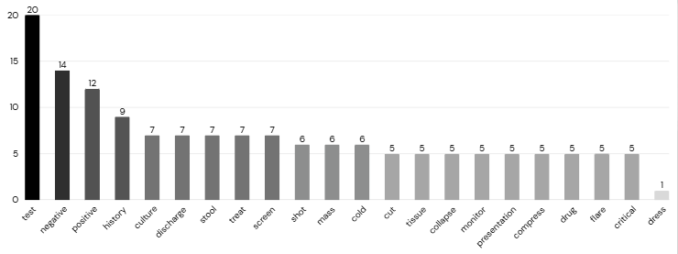
(Source: Research Data)
1. Field: Representing Health Experiences and Medical Activities
The field variable in this study captures the subject matter and experiential domain of Reddit-based medical consultations, primarily focusing on physical symptoms, diagnostic processes, bodily conditions, and treatment actions. Language used by patients reveals a blend of lay expressions and medical register terms that describe concrete health-related events.
Patients often employ material processes to report bodily actions or events, such as “I went to urgent care where they tested me for COVID, strep throat and the flu” and “I reused a pregnancy test and got a positive test.” These processes describe observable, goal-oriented actions involving medical procedures.
Relational processes appear when patients express states of being or evaluations, for instance, “irritant contact dermatitis… it is overall red without patterns”—linking a condition to its descriptive attributes. Additionally, circumstantial elements, such as cause and manner, are used to contextualize experiences (e.g., “after eating leafy veggies so my stool has been greener lately”), reflecting attention to physical patterns and triggers.
Participants are both specific (e.g., “stool,” “glucose,” “white discharge”) and general (e.g., “test,” “flu”), combining personal perspective with formal medical language. Another example, “He advised me to cut out carbs and sugars for 48 hours…”, reveals interaction with medical authority, introducing a treatment recommendation framed by temporal and behavioral circumstances.
Overall, the field component in Reddit consultations reveals a hybridization of discourse—personal storytelling interwoven with medical register terms. This convergence supports the dynamic negotiation between institutional knowledge and user-driven health narratives, a hallmark of participatory digital health communication.
Figure 1. Reddit Consultation Thread Discussing Pre-Test Fasting Instructions
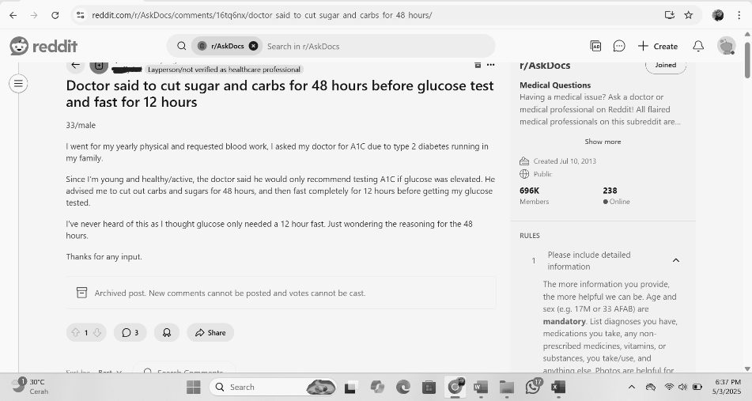
Source: r/AskDocs, screenshot taken May 2025, edited for anonymity.

2. Tenor: Negotiating Roles in an Asymmetrical Yet Casual Setting
In terms of tenor, the interactions exhibit a unique mix of authority and informality. Although doctors occupy the expert role, they often use modal expressions (“It could be…”, “You may want to consider…”) to hedge their advice, acknowledging the limitations of online diagnosis. This softens the authoritative stance and builds a sense of solidarity with patients.
Patients frequently employ expressions of concern, urgency, or confusion, such as “Should I be worried?” or “This has been bothering me for weeks.” These indicate not only a need for information but also emotional reassurance.
This tenor pattern reflects a semi-formal interpersonal dynamic where expertise is respected, but interactional equality is encouraged by the nature of Reddit’s platform.
3. Mode: Asynchronous Written Discourse with Hybrid Features
The mode of communication on Reddit is written, asynchronous, and public. Patients post initial messages often resembling informal blog entries using paragraphs, bullet points, or casual punctuation. These posts are structured linearly, sometimes including headers like “Background,” “Symptoms,” or “Timeline,” indicating a self-organized rhetorical strategy.
Doctors’ replies, though professional, follow the conversational mode of Reddit by being concise, friendly, and often empathetic. Structural features such as:
• Paragraph breaks
• Use of lists or numbered advice
• Occasional emphasis (e.g., italic or bold)
indicate a blending of written medical discourse with digital social conventions.
Cohesion is maintained through lexical repetition (“pain,” “symptoms,” “concern”) and referential ties, although coherence sometimes depends on shared digital literacy rather than formal transitions. Overall, the mode supports informative yet socially aware communication.
Interpretation and Contribution
The findings demonstrate how Reddit consultations function as a hybrid registering institutional medical norms with participatory digital practices. Field is adapted to convey both lay and clinical perspectives, tenor is modulated to balance expertise and accessibility, and mode supports asynchronous, community-facing interaction.
This supports Yus’s (2011) notion of cyberpragmatics and extends Halliday’s register theory into digitally mediated expert-lay exchanges. Unlike institutional settings, Reddit allows doctors to communicate not only medically but socially, adjusting registers to fit the expectations of online help-seeking culture
CONCLUSION
This study examined how registering is realized in online medical consultations on Reddit, using Halliday’s Systemic Functional Linguistics framework—focusing on field, tenor, and mode. Based on the analysis of 100 consultation threads from r/AskDocs, several key patterns emerged that reveal how language is shaped by the digital medical consultation setting.
In terms of field, patients describe symptoms using experiential and narrative language, while doctors respond with clinical reasoning blended with lay-friendly terms. The tenor reflects an asymmetrical relationship—doctors retain authority, but communicate with empathy, modality, and politeness, reducing social distance. The mode is characterized by written, asynchronous interactions that incorporate both professional clarity and informal digital conventions.
These findings indicate that Reddit-based consultations operate as a hybrid register, combining features of institutional medical discourse with the affordances of participatory online platforms. Language is adapted to meet both informational and interpersonal needs, shaped by anonymity, lack of face-to-face interaction, and open accessibility.
Theoretically, this research contributes to the expanding field of digital discourse analysis, offering insights into how register theory can be applied in online health contexts. Practically, the study underscores the importance of language adaptability in digital health communication, suggesting that empathy, clarity, and accessibility are essential for effective medical interaction on platforms like Reddit.

REFERENCES
Ainiyah, N. (2021). Register analysis of language used by the seller and the buyers online shop transaction (Undergraduate thesis, UIN Sunan Ampel Surabaya). https://digilib.uinsby.ac.id/46211/
Eggins, S. (2004). An introduction to systemic functional linguistics (2nd ed.). Continuum.
Eggins, S., & Slade, D. (1997). Analysing casual conversation. Cassell.
Ferguson, G. (2013). English for medical purposes. In B. Paltridge & S. Starfield (Eds.), Thehandbook of English for specific purposes (pp. 243–260). Wiley Blackwell.
Fitria, T. N. (2021). Register used in online language learning during COVID-19 pandemic. ELT in Focus, 4(1), 49–56. https://doi.org/10.35706/eltinfc.v4i1.5251
Garnida, S., Sudarwati, S., Rahayu, A., & Bay Kurniawan, A. (2025). Lexical Cohesion of the Expression of Rebellion of Madeline Miller’s Circe. PARAFRASE : Jurnal Kajian Kebahasaan & Kesastraan, 24(2), 85-97. https://doi.org/10.30996/parafrase.v24i2.11635
Halliday, M. A. K. (1978). Language as social semiotic: The social interpretation of language and meaning. Edward Arnold.
Halliday, M. A. K. (1985). An introduction to functional grammar (1st ed.). Edward Arnold.
Halliday, M. A. K., & Hasan, R. (1989). Language, context, and text: Aspects of language in a social-semiotic perspective (2nd ed.). Oxford University Press.
Jones, R. H. (2009). Health and risk communication: A discourse-based approach. In R. Wodak & M. Meyer (Eds.), Methods of critical discourse analysis (pp. 172–190). SAGE.
Kilgo, D. K., Yoo, J., & Johnson, T. J. (2019). Spreading Ebola panic: Newspaper and social media coverage of the 2014 Ebola health crisis. Health Communication, 34(8), 811–817. https://doi.org/10.1080/10410236.2018.1437524
Leech, G. (1983). Principles of pragmatics. Longman.
Martin, J. R., & Rose, D. (2007). Working with discourse: Meaning beyond the clause (2nd ed.). Continuum.
Massanari, A. (2015). Participatory culture, community, and play: Learning from Reddit. Peter Lang Publishing.
Nunan, D. (1993). Introducing discourse analysis. Penguin Books.
Paltridge, B. (2021). Discourse analysis: An introduction (3rd ed.). Bloomsbury Publishing.
Qoyyimah, U. (2016). Revealing register in English classroom: A functional grammar perspective. International Journal of English and Education, 5(1), 139–149.
Qoyyimah, U. (2017). Teaching register in EFL writing class. LLT Journal: A Journal on Language and Language Teaching, 20(1), 10–18.
Rahmah, M. (2023). A functional analysis of register in medical consultations on Reddit (r/AskDocs) (Undergraduate thesis, Universitas 17 Agustus 1945 Surabaya).
Rukmini, D., & Padmadewi, N. N. (2013). Discourse competence in language teaching. TEFLIN Journal, 24(1), 18–28.
Santosa, R. (2003). Semantik leksikal. Universitas Sebelas Maret Press.
Saragih, A. (2014). Introducing systemic functional linguistics. International Journal of English and Education, 3(2), 446–458.
Sharma, E., & De Choudhury, M. (2018). Mental health support and its relationship to linguistic accommodation in online communities. In Proceedings of the 2018 CHI Conference on Human Factors in Computing Systems (pp. 1–13). ACM. https://doi.org/10.1145/3173574.3174215
Sudaryanto. (2015). Metode dan aneka teknik analisis bahasa. Sanata Dharma University Press.
Sugiharti, D., & Pariyanto, P. (2021). LEXICAL VARIATION OF MADURESE SPOKEN IN BANGKALAN, MADURA. PARAFRASE : Jurnal Kajian Kebahasaan & Kesastraan, 21(1). https://doi.org/10.30996/parafrase.v21i1.5253
Suhadi, S. (2016). Register used in online forums. Register Journal, 9(1), 14–31. https://doi.org/10.18326/rgt.v9i1.14-31
Thompson, G. (2014). Introducing functional grammar (3rd ed.). Routledge.
Yus, F. (2011). Cyberpragmatics: Internet-mediated communication in context. John Benjamins Publishing.

