Kegiatan Magang di PT. Kereta Api Indonesia (PERSERO) Daop 8 Surabaya.docx
by - Turnitin

Submission date: 06-Jul-2024 05:22PM (UTC+0300)
Submission ID: 2413101655
File name: Kegiatan_Magang_di_PT._Kereta_Api_Indonesia_PERSERO_Daop_8_Surabaya.docx (3.43M)
Word count: 1254
Character count: 8186

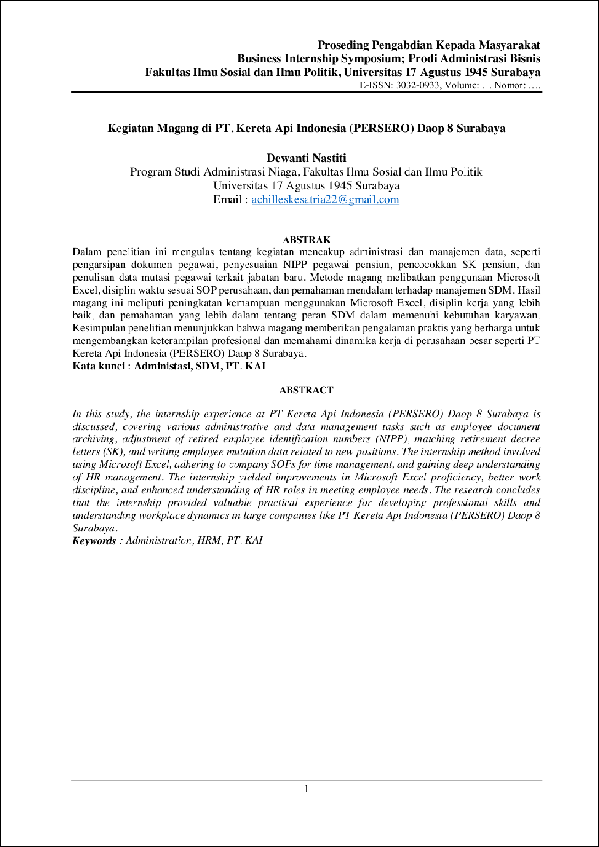

1

7

3

10

2

9

14

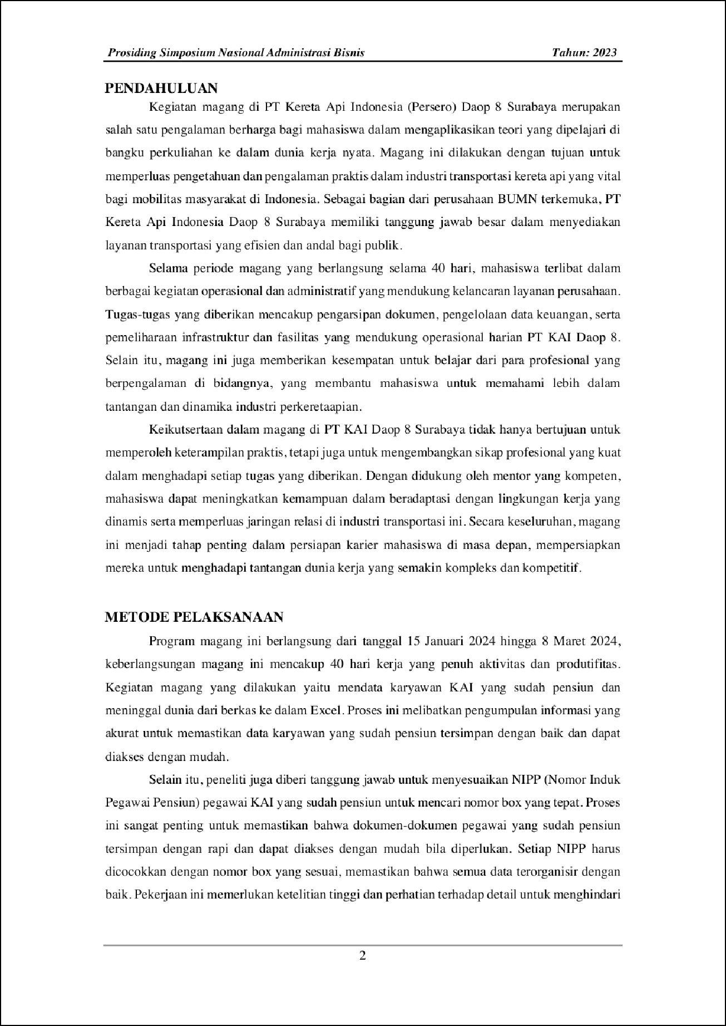

4

13

16

2

18

11

15

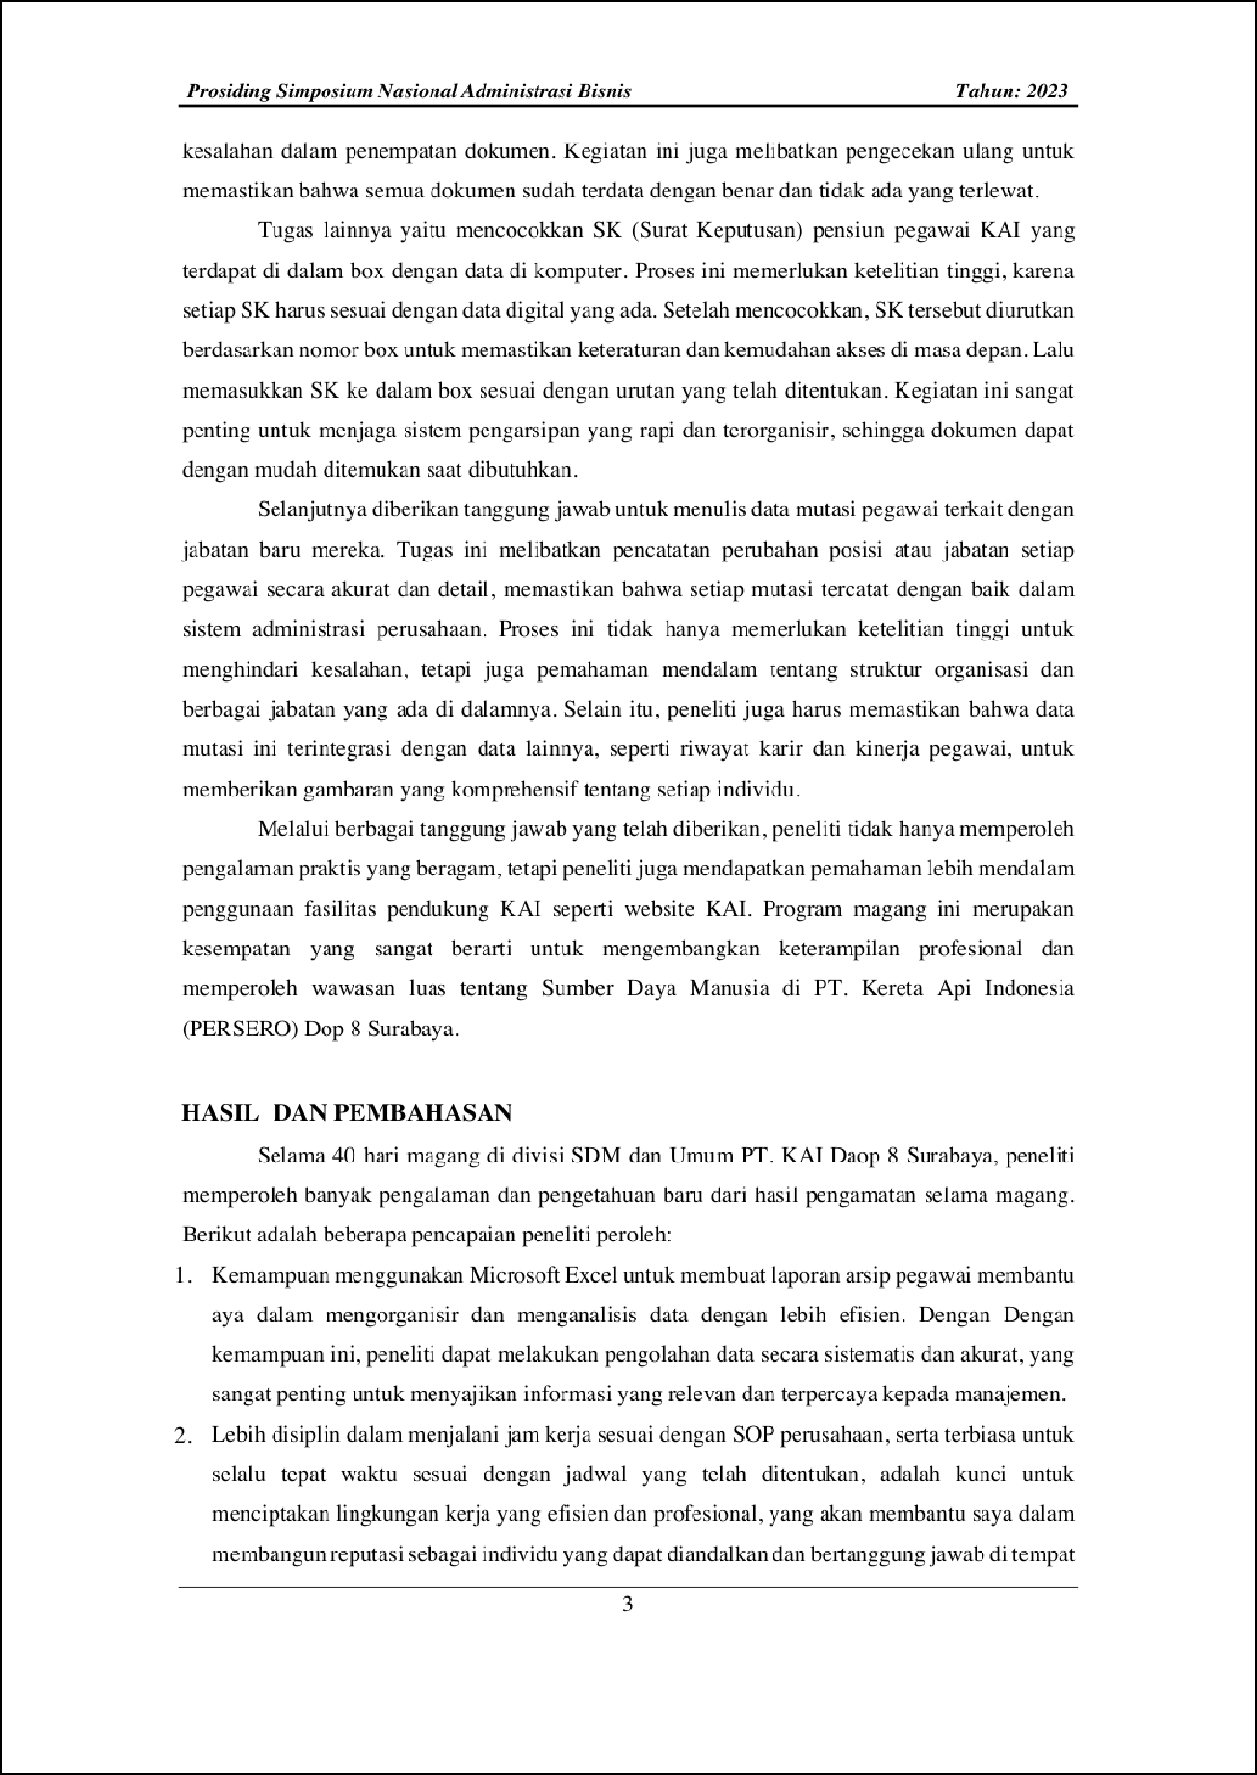

17

8

12

19

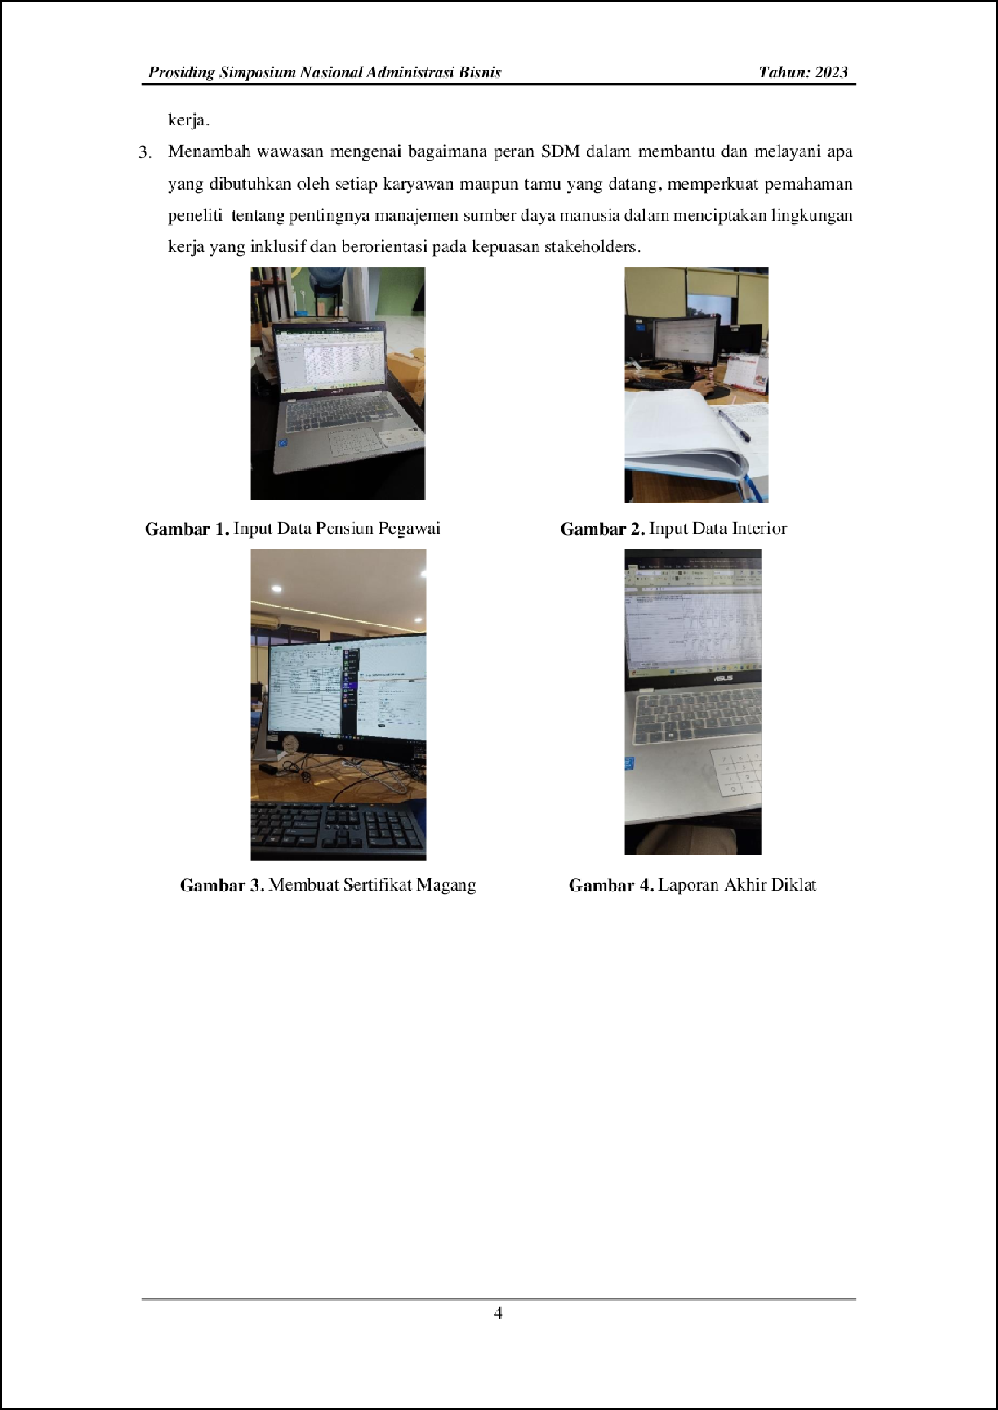

6

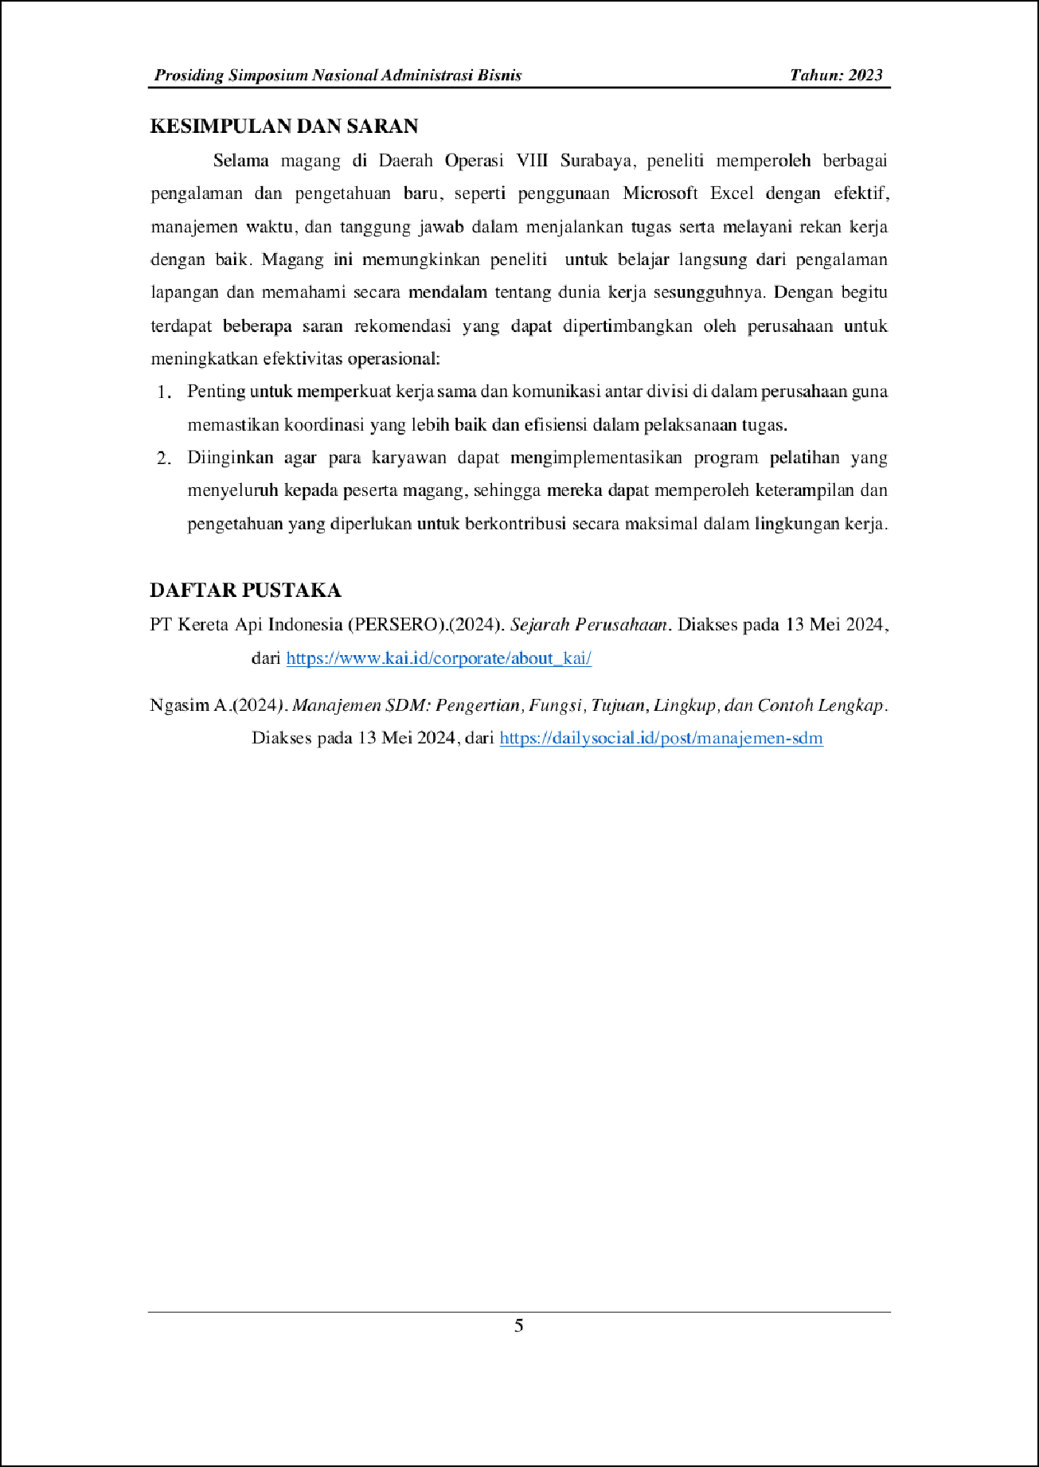

5

Kegiatan Magang di PT. Kereta Api Indonesia (PERSERO) Daop 8 Surabaya.docx

ORIGINALITY REPORT
16

%
SIMILARITY INDEX
15%
INTERNET SOURCES
5%
PUBLICATIONS
3%
STUDENT PAPERS

PRIMARY SOURCES
1 Submitted to Universitas 17 Agustus 1945 Surabaya
Student Paper
1%
1

digilib.uinsby.ac.id
Internet Source %
2
1%

3 Nur Dilla Komalasari, Anggraeny Puspaningtyas, Joko Widodo. "PENGEMBANGAN UMKM SENTRA KULINER DESA PEKARUNGAN MELALUI FASILITASI PIHAK EKSTERNAL DAN POTENSI EKONOMI
LOKAL", Jurnal Mediasosian : Jurnal Ilmu
Sosial dan Administrasi Negara, 2022
Publication
1

eprints.perbanas.ac.id
Internet Source %
4
1

pintu.co.id
Internet Source %
5
1

123dok.com
Internet Source %
6

7

8

9

10

11

12

13

14

15

16

17

18
onesearch.id
Internet Source %
1

aunilo.uum.edu.my
1
Internet Source %

garuda.ristekdikti.go.id
1
Internet Source %

media.neliti.com
1
Internet Source %

news.bsi.ac.id
1
Internet Source %

ppds.fk.ulm.ac.id
1
Internet Source %

repository.fe.unj.ac.id
1
Internet Source %

www.researchgate.net
1
Internet Source %

zustiana.blogspot.com
1
Internet Source %

digilib.isi.ac.id
1
Internet Source %

ﬁsip.ubb.ac.id
1
Internet Source %

lintaspacitan.blogspot.com
1
Internet Source %

19
projects.co.id
Internet Source %
1

Exclude quotes Oﬀ Exclude bibliography On
Exclude matches Oﬀ

